V1.1

Contents

Download Unity3d trial, Download de_aztec sample scene (for you its cs_italy now) 2

Remove everything but spawns 2

Rename de_aztec to cs_italy 3

Open crafy tools->View->file system browser, Add counter strike folder and open map 3

File->Export map to obj file 4

In 3dsmax import obj file 4

Rotate it And Optimize map by hitting Detach button(not nesssery) 5

Export map to unity3d project Assets folder ( Embend media checked and Scene units are centementers) 6

Drag cs_italy to scene 7

Select fbx model, Generate colliders ,generate lightmap, Apply 7

Then cs_italy ->Static 8

GameObject->Create Directional Light, shadows ->soft shadows 8

Windows->lightmapping->bake Scene 8

Place Spawns 9

Select cs_italy then Rtools->build 9

Now you have map file, copy it to android device and play 10

## Download [Unity3d trial](http://unity3d.com/), Download [de_aztec sample](http://depositfiles.com/files/7pl6bu6hq) scene (for you its cs_italy now)

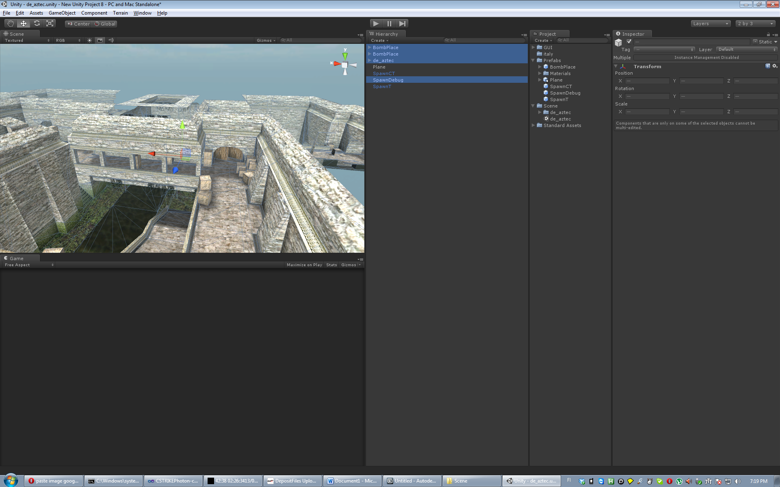

## Remove everything but spawns

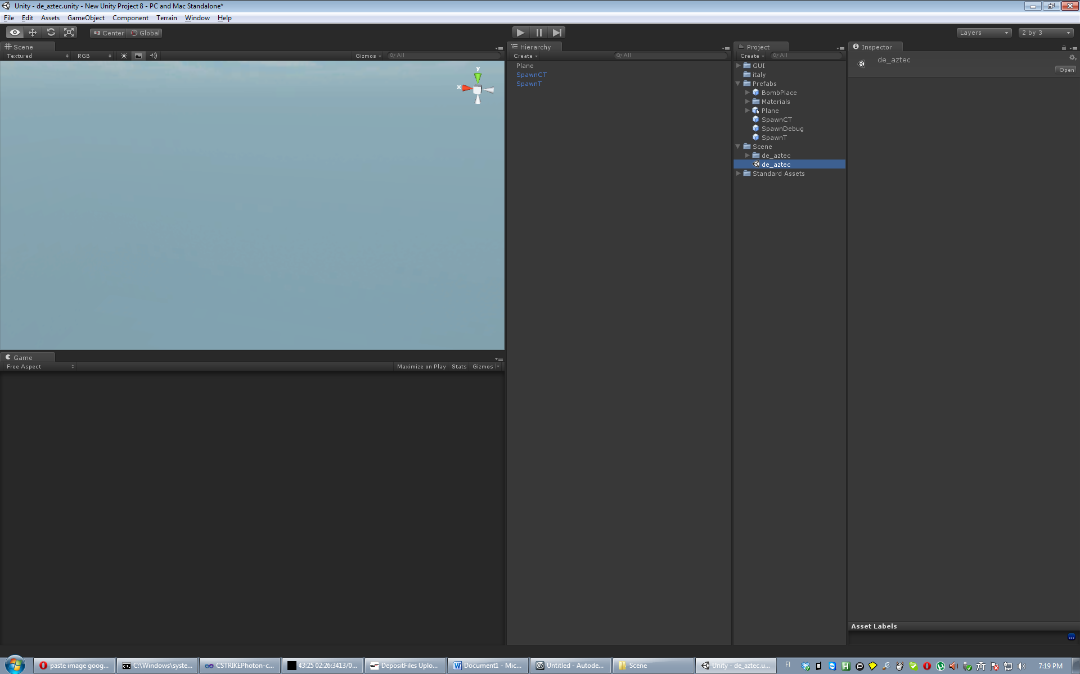

## Rename de_aztec to cs_italy

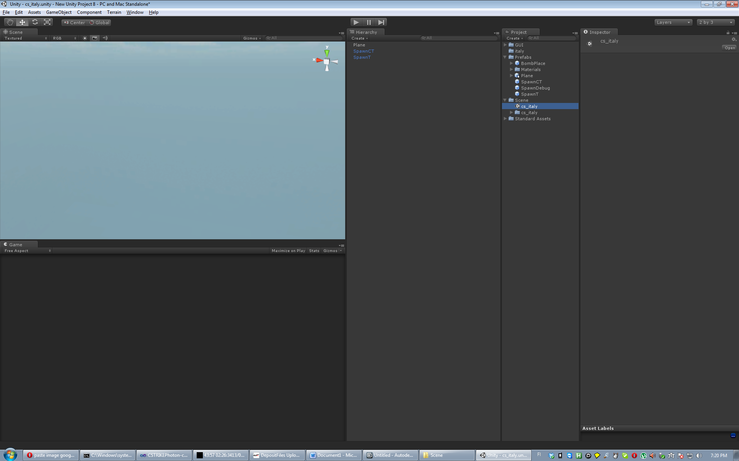

## Open [crafty tools](http://nemesis.thewavelength.net/index.php?p=45)->View->file system browser, Add counter strike folder and open map

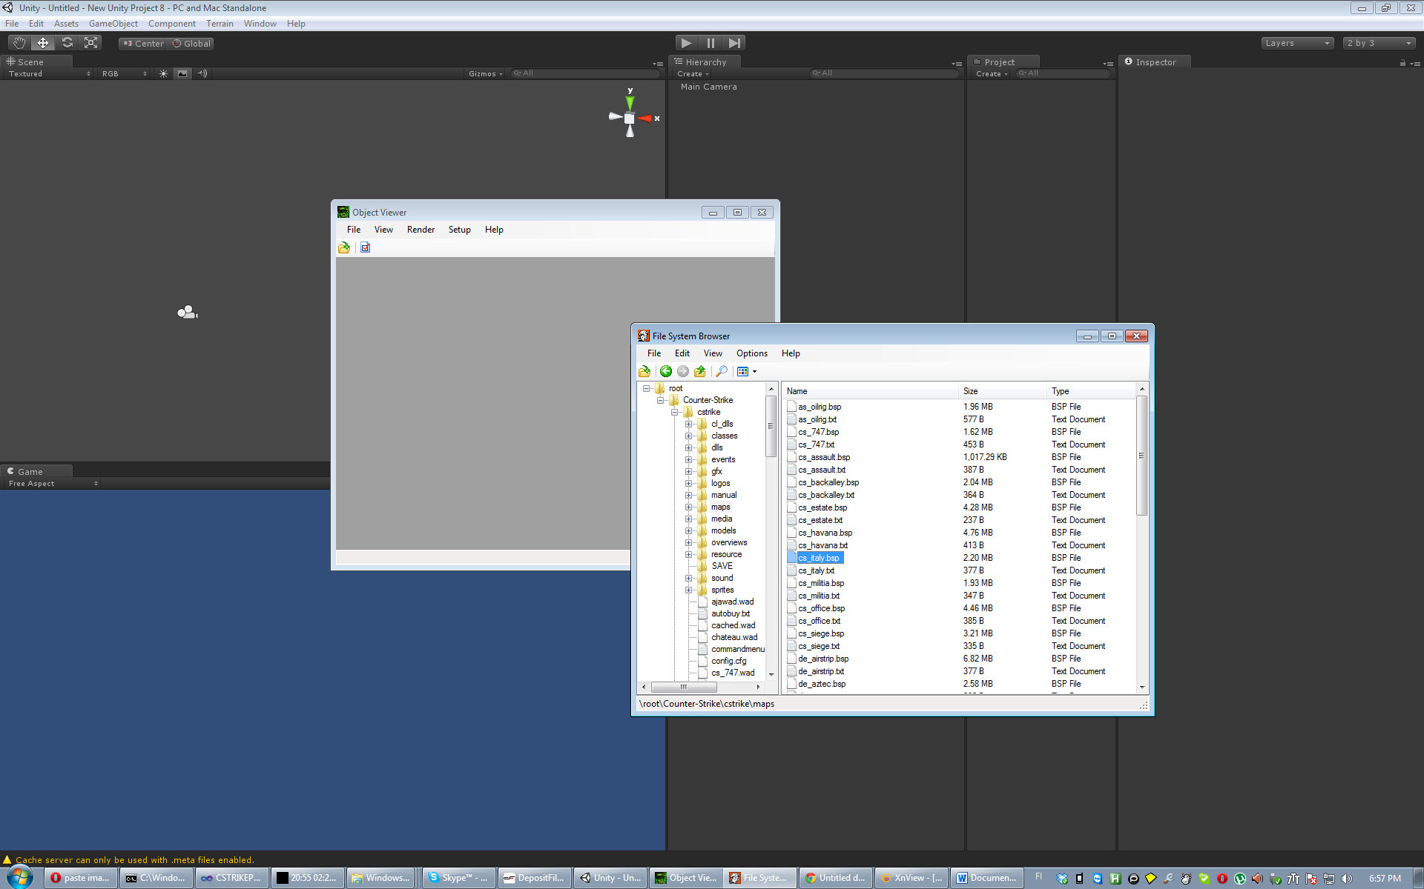

File->Export map to obj file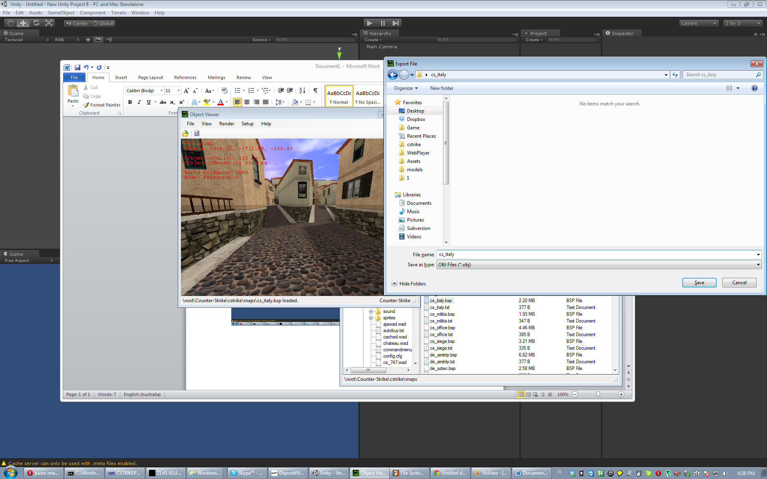

## In 3dsmax import obj file

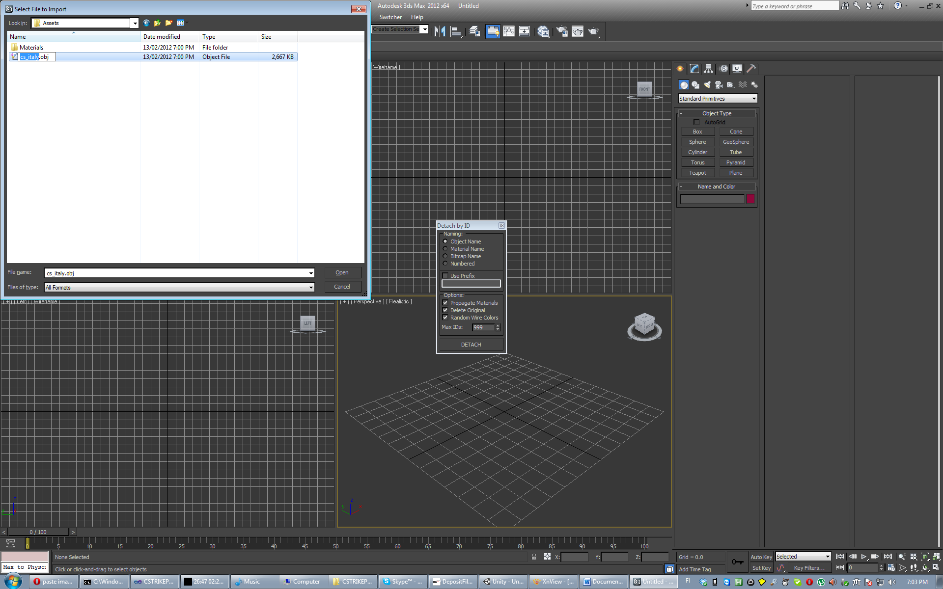

## Rotate it And Optimize map by hitting Detach button(not nesssery)

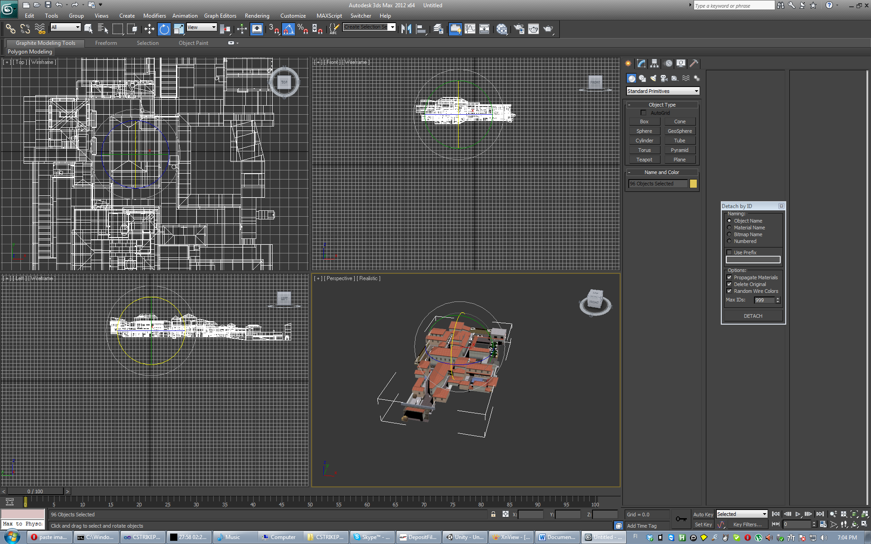

## Export map to unity3d project Assets folder ( Embend media checked and Scene units are centementers)

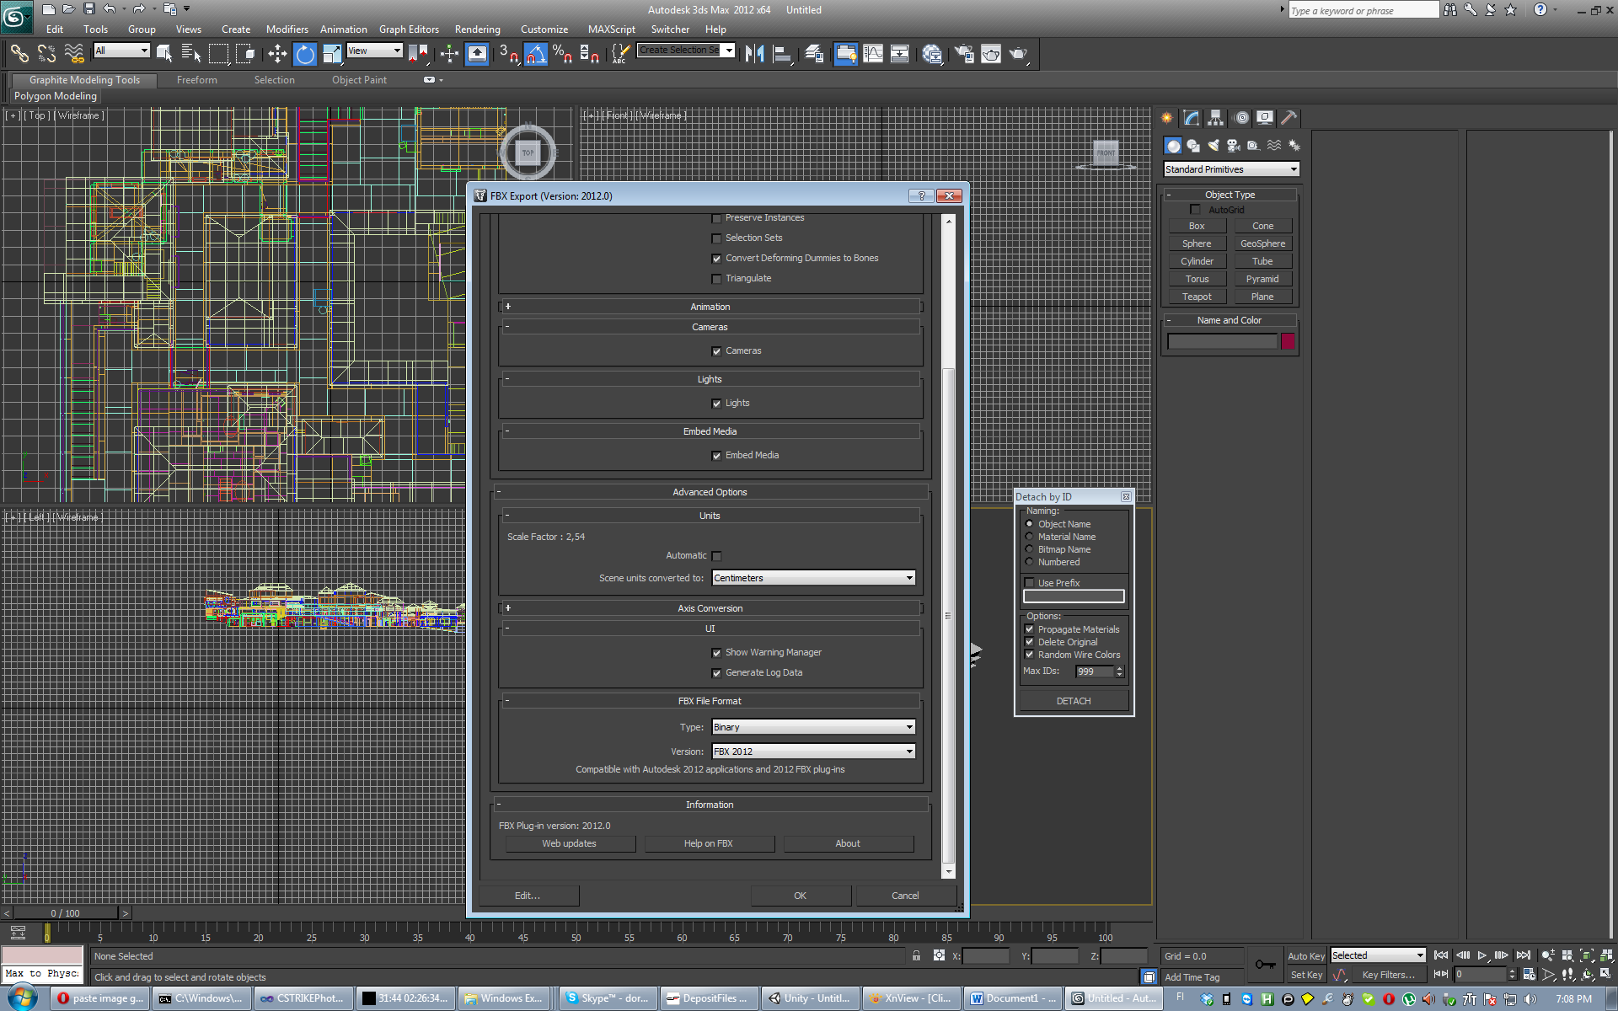

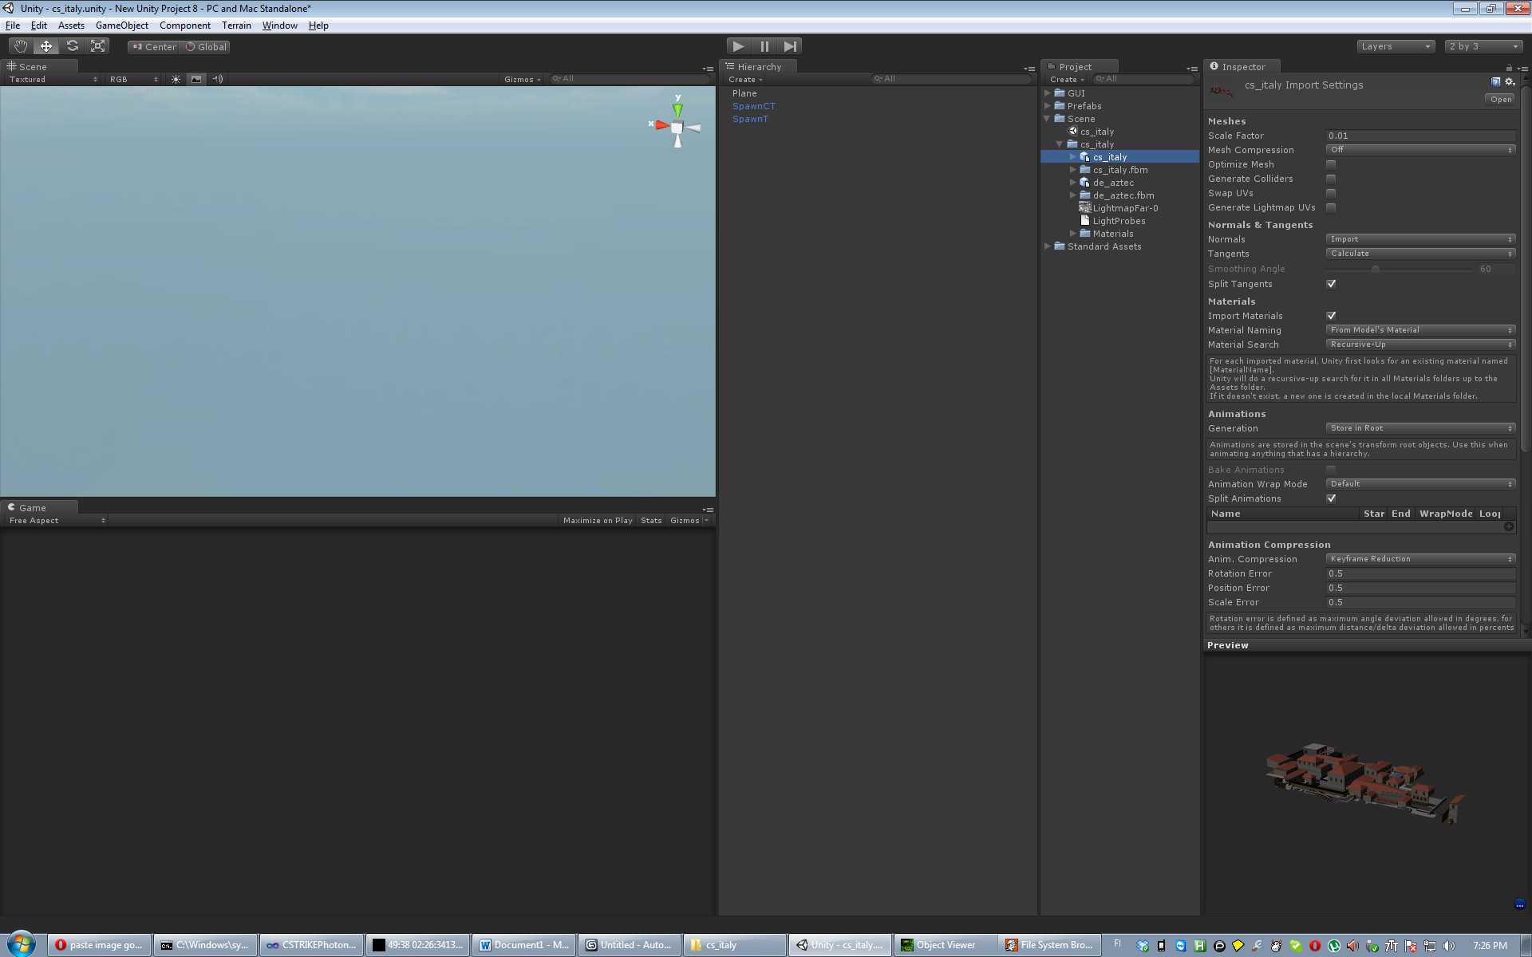

## Drag cs_italy to scene

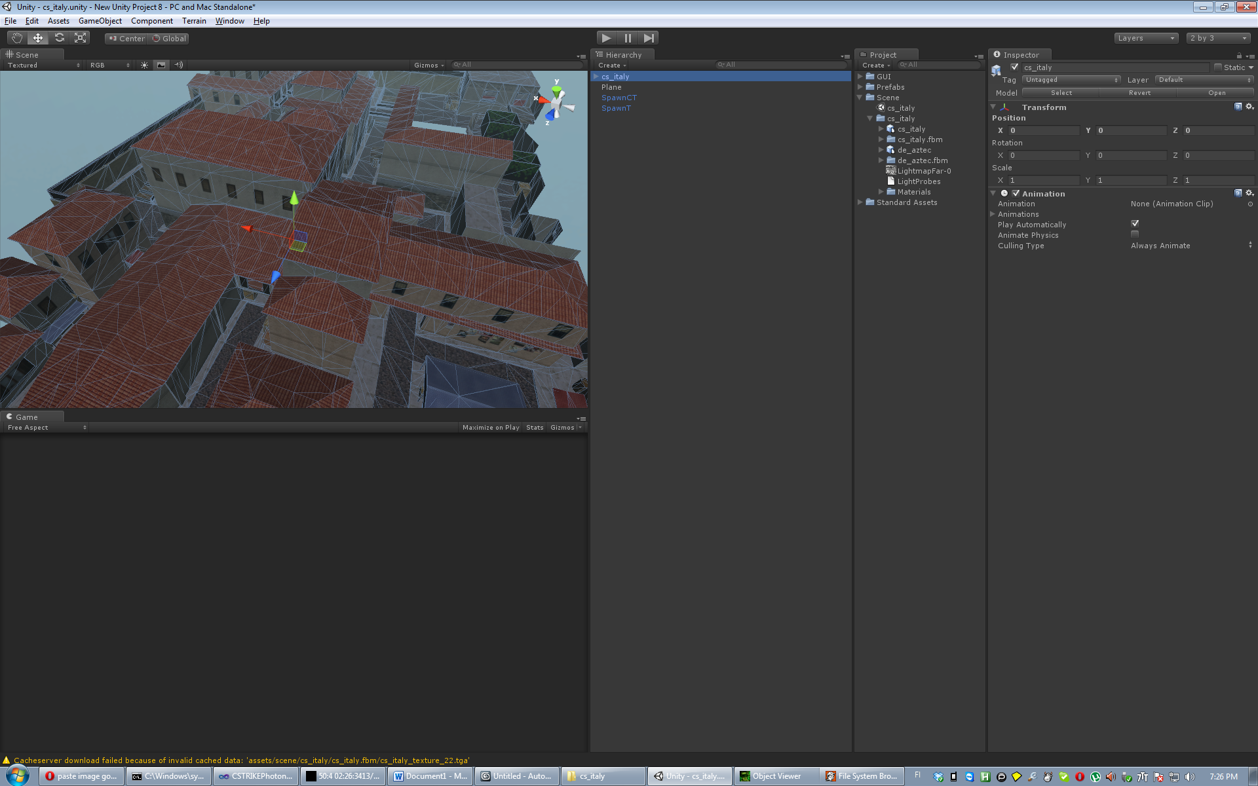

## Select fbx model, Generate colliders ,generate lightmap, Apply

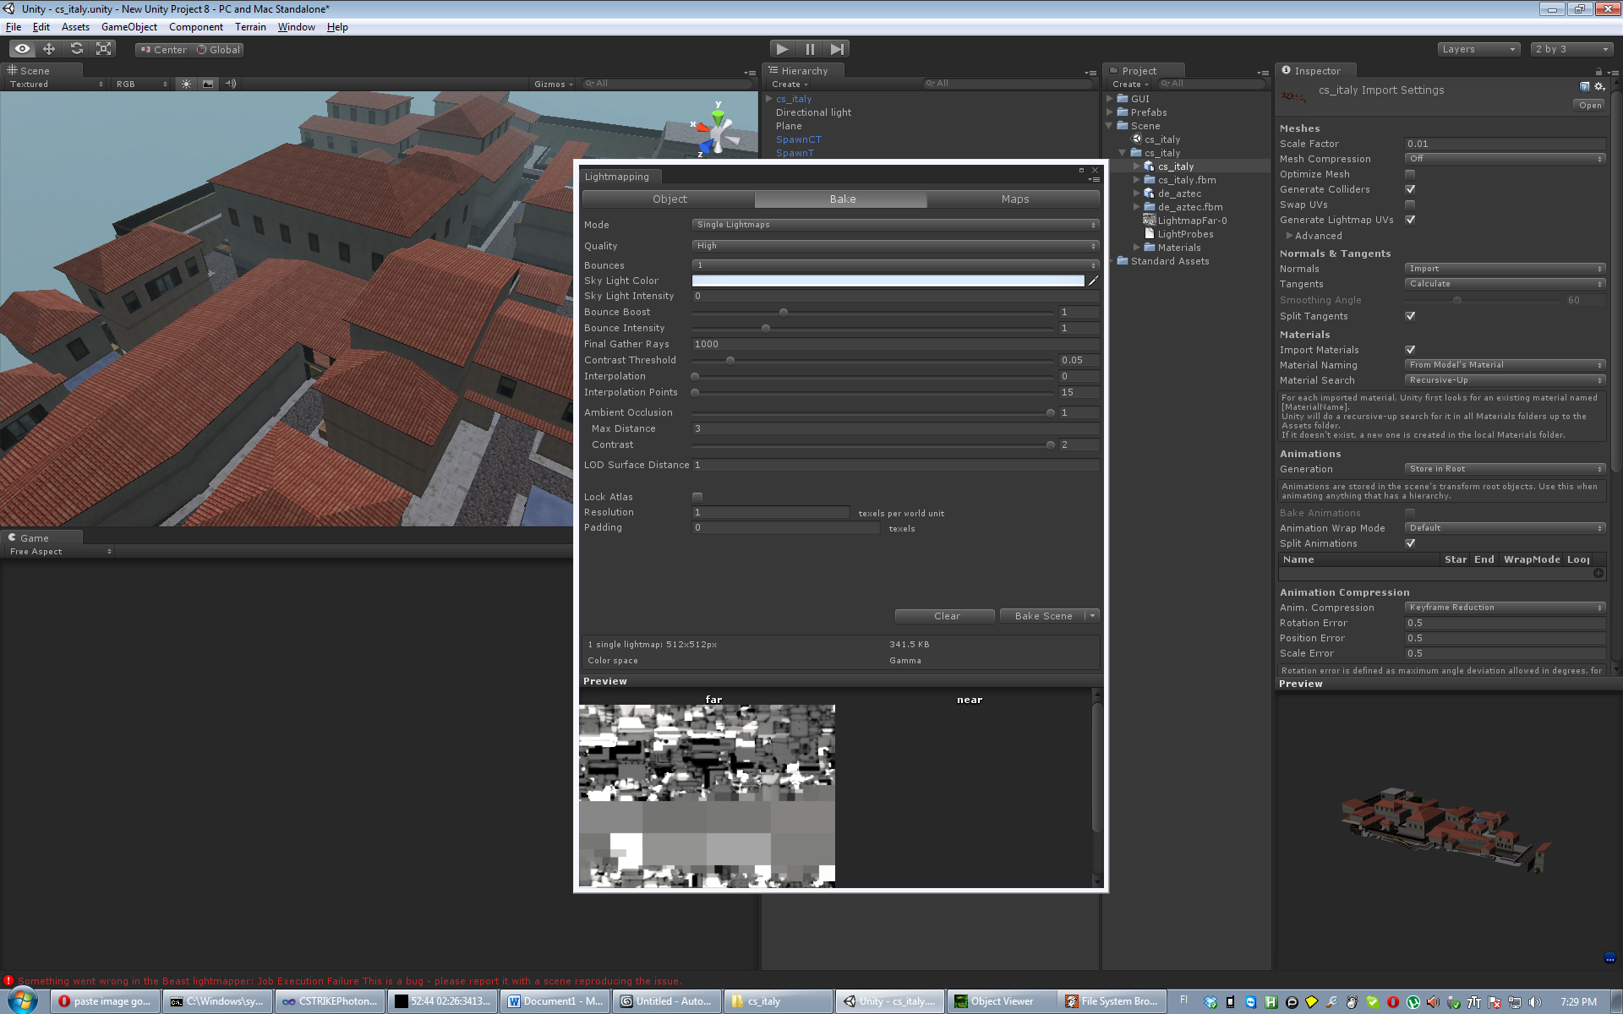

## Then cs_italy ->Static

## GameObject->Create Directional Light, shadows ->soft shadows

## Windows->lightmapping->bake Scene

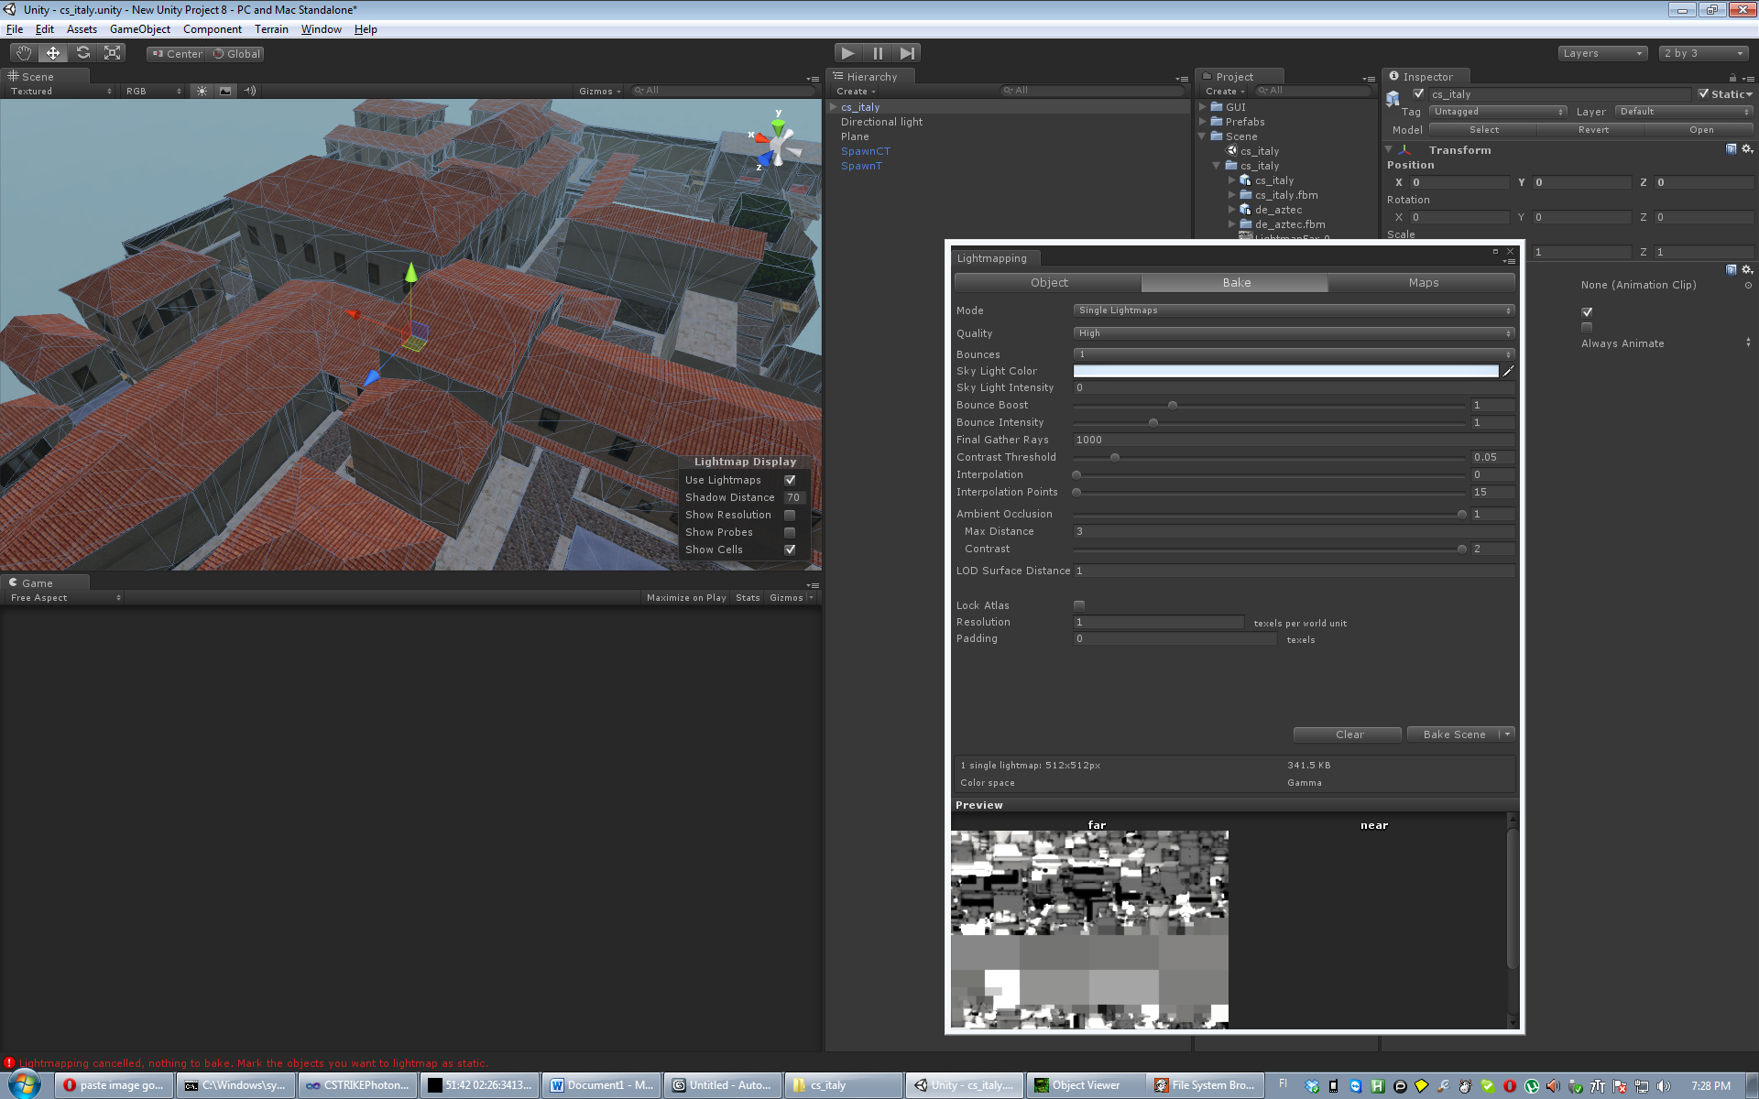

Layer Level

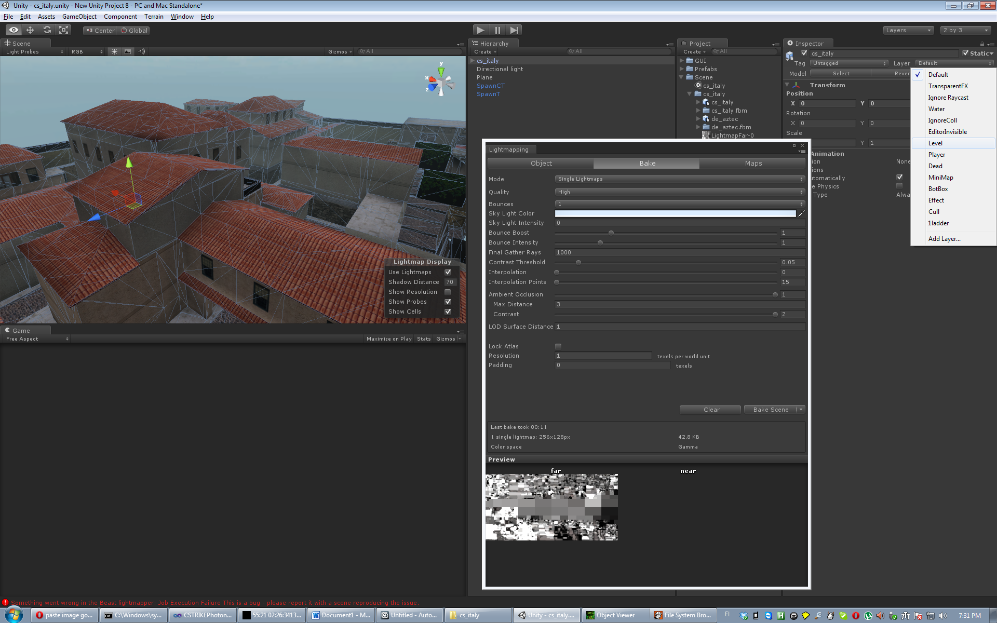

## Place Spawns

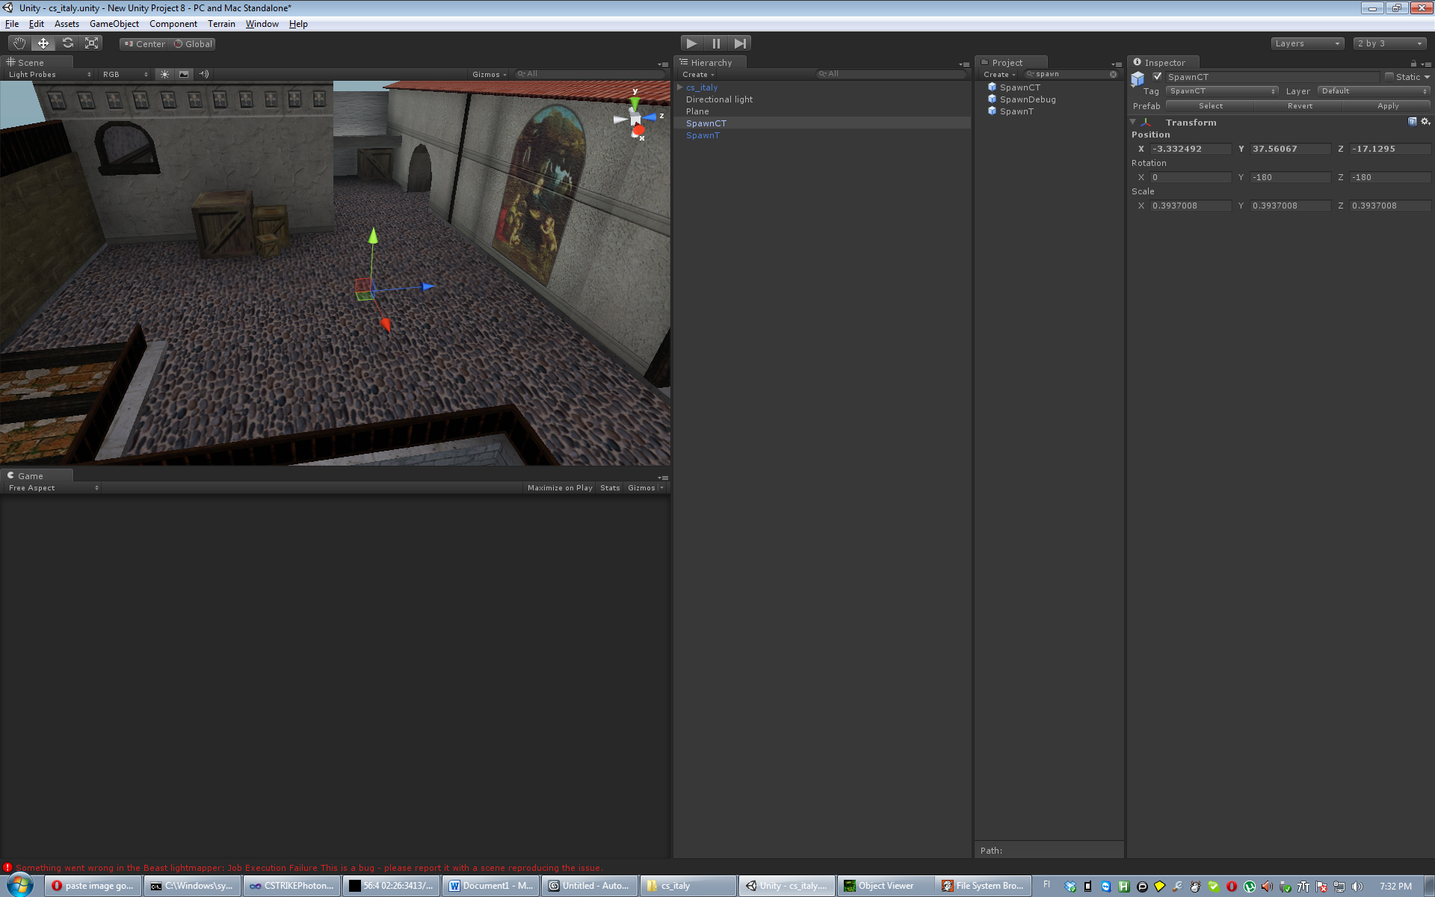

## Select cs_italy then Rtools->build

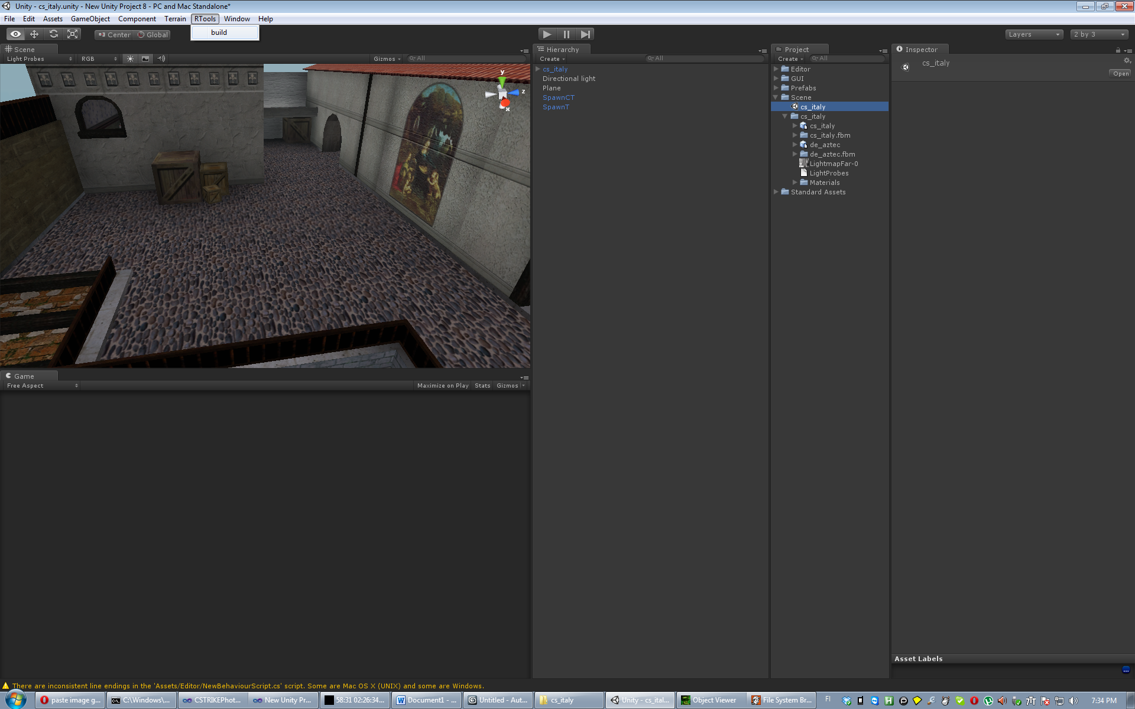

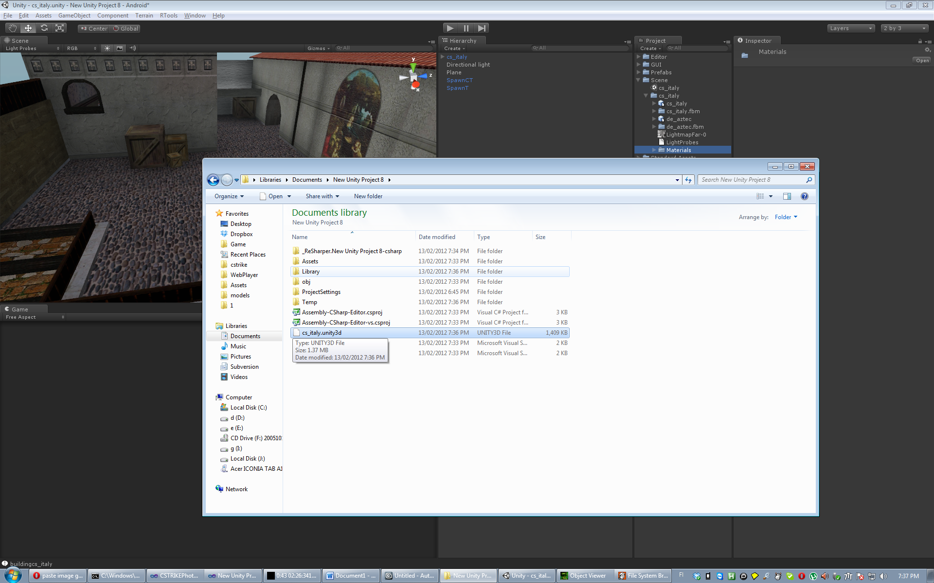

## Now you have map file, copy it to android device and play

